Final Project Proposal: Mapping Survey Transects Using Photo Locations

**Abstract:**

The Salas y Gómez Ridge runs between mainland South America and Easter Island, and contains numerous seamounts which are habitat for many endemic species. As well as being ecologically important, seamounts also hold economic value as locations for fishing, trawling, and even deep-sea mineral mining as well. Due to the depths at which seamounts are most commonly found, advanced technology and equipment, as well as funding is often needed to reach and study these environments, which has led to the habitats remaining understudied, particularly in regions such as the Salas y Gómez Ridge. A research cruise in 2019 completed video transects of a number of seamounts along the ridge, as well as two oceanic islands. Analysis of these videos will provide important information regarding the ecosystems present in the region.

**Background/Introduction:**

Seamounts are structures which rise up 1000 meters or more from the seabed and provide important habitat for many organisms. A large number of seamounts are found in the Pacific Ocean, and on the Nazca plate there are several chains of seamounts including the Salas y Gómez Ridge. These seamounts and the islands along the chain including Easter Island were formed as a hotspot moved from west across the Nazca plate (Ray et al., 2012).

The communities on seamounts are thought to be particularly important, and may even be thought of as refuges and hotspots or oases of abundance, biodiversity, and biomass, and may act as a sort of stepping-stone for the dispersal of organisms through the ocean (Rowden et al., 2010). However, these communities are also particularly vulnerable to the effects of overfishing, trawling and more, and have been found to have low resiliency. The Salas y Gómez Ridge in particular is unique due to its unique location in the oligotrophic waters of the South Pacific subtropical gyre and Humboldt current as well as an oxygen minimum zone which have led to high endemism in the region (Wagner et al., 2021). Further studies along the ridge will provide important information regarding the habitats and communities. I aim to assess and analyze the habitat, and further in my thesis research I will continue the research with an assessment of the organisms present as well.

**Methods:**

Several seamounts and two oceanic islands were surveyed as part of the EPIC Cruise in 2019 between Chile and Easter Island. An ROV equipped with numerous cameras as well as environmental sensors began at the base of each seamount and island and surveyed them moving towards the peak. From these videos images have been taken as screengrabs at one minute intervals throughout the duration of each transect from a downward facing high definition camera. The time stamps of these images will then be used to match to files with the latitude and longitude for the ROV throughout the survey. From these a point can be mapped for each photo to track the path of the survey.

Additional data may be added from files containing the salinity and temperature. There is also detail bathymetric data from the surveys as well, though I do not know exactly where the files are, ideally I would like to map the transects with the regional bathymetry. I hope to be making progress on my habitat analysis of these images as well, and if I have collected sufficient data this could be integrated into the project as well. This could include analysis of substrate type, or perhaps locations of bioturbation, or more. This project will provide information and answer questions about the benthic habitat of seamounts in the region, as well as hopefully showing how it may change with environmental factors such as temperature and depth. For the purpose of this project, I will start by just analyzing two seamounts so as to not try and attempt too much.

**Timeline:**

4/7 - Select photos for analysis

4/11 – Complete a basic level habitat analysis

4/14 - Complete collection of latitude and longitude datapoints for transect photos

4/18 - Map photo locations

4/21 - Add data to maps

5/2 - Finalize research paper and presentation

**Figure**

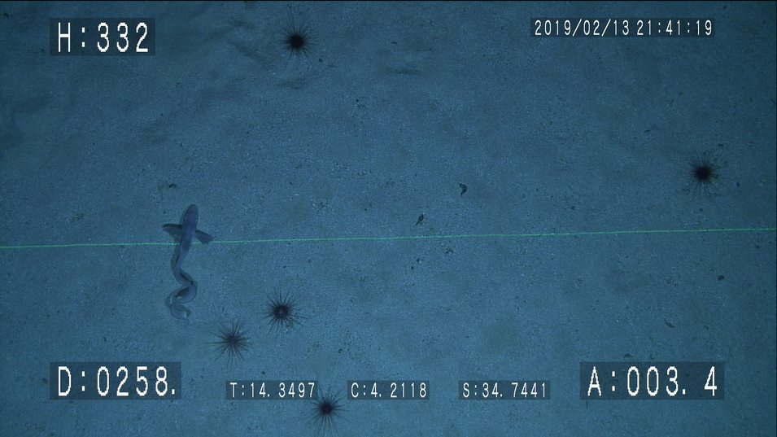

Figure 1. An image taken from the peak of a seamount along the Salas y Gómez Ridge shows urchins and a ateleopid fish.

**References**

Ray, J.S., Mahoney, J.J., Duncan, R.A., Ray, J., Wessel, P., Naar, D.F., 2012. Chronology and Geochemistry of Lavas from the Nazca Ridge and Easter Seamount Chain: an 30 Myr Hotspot Record. Journal of Petrology 53, 1417–1448. https://doi.org/10.1093/petrology/egs021

Rowden, A.A., Dower, J.F., Schlacher, T.A., Consalvey, M., Clark, M.R., 2010. Paradigms in seamount ecology: fact, fiction and future: Paradigms in seamount ecology. Marine Ecology 31, 226–241. https://doi.org/10.1111/j.1439-0485.2010.00400.x

Wagner, D., van der Meer, L., Gorny, M., Sellanes, J., Gaymer, C.F., Soto, E.H., Easton, E.E., Friedlander, A.M., Lindsay, D.J., Molodtsova, T.N., Boteler, B., Durussel, C., Gjerde, K.M., Currie, D., Gianni, M., Brooks, C.M., Shiple, M.J., Wilhelm, T. ‘Aulani, Quesada, M., Thomas, T., Dunstan, P.K., Clark, N.A., Villanueva, L.A., Pyle, R.L., Clark, M.R., Georgian, S.E., Morgan, L.E., 2021. The Salas y Gómez and Nazca ridges: A review of the importance, opportunities and challenges for protecting a global diversity hotspot on the high seas. Marine Policy 126, 104377. https://doi.org/10.1016/j.marpol.2020.104377